Enable/Disable Online ordering:
Scenario: FC is contacting us because they need to enable or disable online ordering.

- Log into the AX5 point-of-sale system with your PIN.
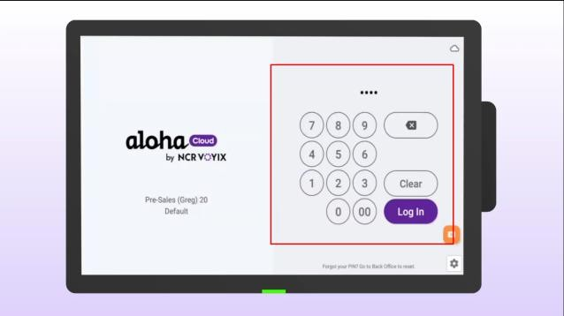
- Click the menu in the top left corner of the screen.
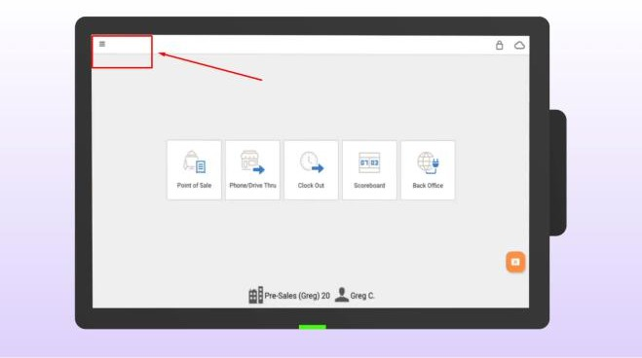
- Select SETTINGS.
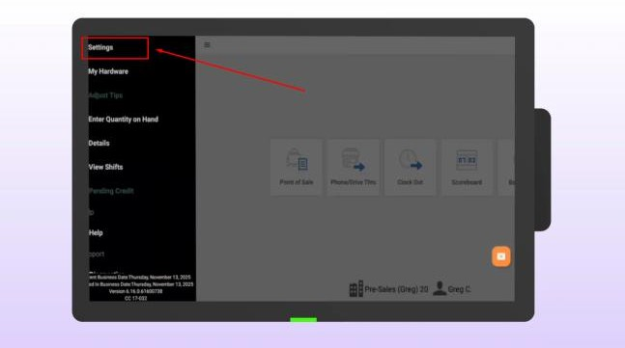

- Scroll down and check the box to process online orders.
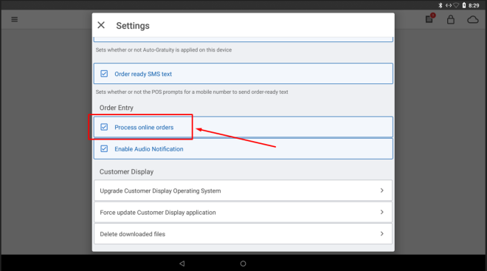
- Look for the “Online Orders” icon to appear, which confirms that the device is ready.
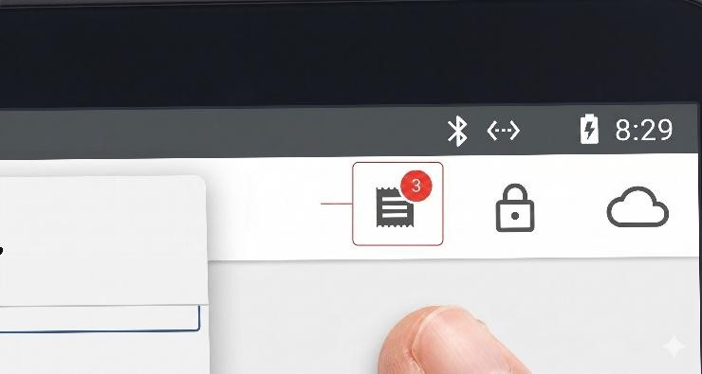
- To disable online ordering, follow the same procedure.
- Go to SETTINGS.
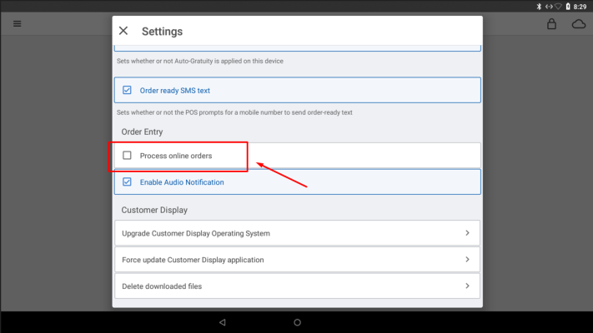
- Scroll down and uncheck the box to process online orders.

- Look for the “Online Orders” icon to disappear, which confirms that online ordering has been disabled.
